High Carrier Density effects
Last time we mentioned that very high carrier densities in the active region can have adverse effects. At such very high densities the Auger effect can take place. “Auger recombination” is where an electron in the conduction band is promoted higher in the conduction band as a second electron drops to the valence band. Thus the energy lost by the electron falling to the conduction band is transferred to the other electron, which then drops back to the bottom of the conduction band non radiatively. Note as for any transition momentum must also be conserved.
This process requires a high density of electrons in the conduction band for it to become significant. In fact the effect scales as the cube of the free carrier density. When an LED is driven hard (high current) or in a laser it is possible for these effects to become significant loss mechanisms.
The effect is normally associated with narrow gap materials such as Infrared emitters. However, it has been claimed as a loss mechanism in wide bandgap blue green LEDs, possibly linked with defect states, although this is a source of controversy. Whatever the case there is no doubt that there are high current density loss mechanisms that lead to so-called “current droop” where the intensity of the LED no longer increases linearly with current, even taking into account heating effects. In the latest LEDs the devices are specficially designed to operate at high current densities, using more quantum wells or none at all. Often their performance is poor at lower currents compared to conventional designs.

Semiconductor Materials
Up until now we have concentrated on the semiconductor engineering and device priniciples. We have not discussed in detail the materials we plan to use, other than they are usually III-V semiconductors, and for emitters they need to have a direct bandgap.
So what materials can we use?
As discussed on many occasions we can split the semiconductor materials into two groups: III-V semiconductors for Orange-Red-Infrared; and III-V(Nitride) semiconductors for Ultraviolet-Blue-Green.

III-V materials for the Red and Infrared
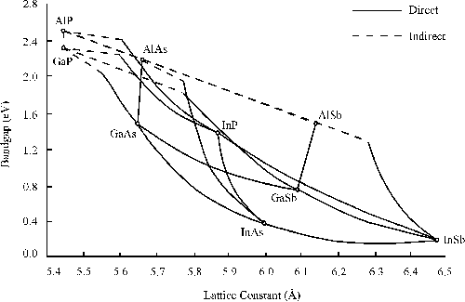
To the left is a graph of the semiconductor bandgap of material against the crystal lattice spacing. The crystal unit cell is cubic so the lattice spacing is the same in all directions.
Lattice spacing is very important. Dislocations in the material degrade the performance dramatically, and lead to shorter device lifetimes. This means we must either prepare all the layers to have the same lattice constant as the substrate we grow them on; or ensure any layers that are strained are so thin that extra dislocations do not form.
For the above materials we have a limited choice of substrates that we can use. These substrates discs of the material that are cut out of a single crystal ingot of the semiconductor. In general they are difficult to prepare. The usual choices are:
1. GaAs 2. InP 3. GaSb
Note that AlAs, AlSb would superficially be good substrates as they have wide bandgaps so would be transparent to the LED emission. However, Al compounds tend to be unstable in air (they tend to oxidise) so care has to be taken in their use.
Examining the chart above GaAs has the smallest lattice parameter and access to the widest bandgap materials. Red LEDs require a bandgap around 1.9-2.0 eV. We can just achieve this using AlGaAs before it becomes indirect gap. AlGaAs has the advantage that the lattice spacing hardly changes as we change the Al contect. Thus it is an easy material to work with. However when we get close the the direct / indirect transition we have two problems: first it is hard to make a Double Heterojunction, or barriers for our quantum wells as there is no direct gap wider material to use; second carriers start to “overflow” into the indirect parts of the conduction band and then would recombine non-radiatively, amongst other issues.
The alternative is to prepare alloys of AlInP and GaInP (or the quaternary AlGaInP). This system has a bandgap extending to around 2.2 eV if we stay lattice matched to GaAs, which allows both Red and Orange LEDs to be made. Yellow LEDs can also be made, but they tend to be poor are we again run out of bandgap. When we make our LED (or Laser) the barrier in the conduction band is small so many of the electrons escape into the p-material. Thus the Injection Efficiency is poor.
Near infrared LEDs, can also be made either using GaAs wells or making the active region contain small amounts of In (the InGaAs alloy). Two common applications are the Infrared LEDs in a remote control unit (around 940 nm) and also at 980 nm one and optically pump transitions in Erbium which then emit at around 1.5 um. Er placed in a fibre can therefore act as an optical amplifier in a fibre optic system.
InP substrates are best known for their use for communication wavelengths. Although the bandgap of InP is large note how it is lattice matched to mid-range compositions of InGaAs, which have bandgaps in the correct region. These are very commonly used in 1.5 and 1.3 micron lasers, with InGaAsP alloys being employed to form the various layers in the structure. It is much harder to get big diameter InP substrates than GaAs (and as a result the wafers are also more expensive). As a result a big area of research is how to get 1.5 um emitters grown on a GaAs substrate.
GaSb is a generally used for long wavelength infrared applications, which are more specialist in nature. Many chemical molecules have absorption bands in this region. Looking for small amounts of absorption as a gas passes between an Led and detector can form a sensitive detection system.
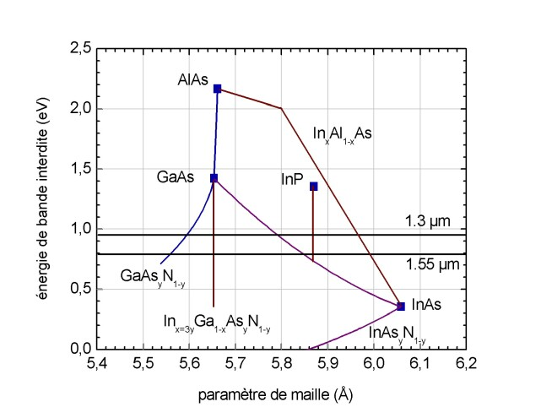
It is very hard to add nitrogen to the above semiconductors. Nitrogen is a very small atom and does not mix well with the other atoms to form a uniform alloys. (The chemistry is quite different but it is superficially analogous to oil and water: they both may be liquids but they don’t like to mix!). However it is possible to get very small amounts of nitrogen into GaAs. Despite the bandgap of GaN being much larger than GaAs it is found that small amounts of nitrogen (about 1 or 2%) in GaAs make the bandgap smaller than GaAs. By adding In we can start to get bandgaps towards the communication wavelengths without needing to use InP.
An alternative is make the InGaAs spontaneously form small dots of material (quantum dots) which if small enough can remain strained. These approaches both work for 1.3 micron lasers, but 1.55 micron devices are significantly harder.

Wide Bandgap Semiconductor materials
Red LED and lasers were both demonstrated and available in the 1990s. However, there was a drive to obtain Blue and Green emitters. The main reason was that a blue laser can be focussed to a significantly smaller spot than a red laser. This means that we can have more pits on an optical disc (CD, DVD, Blu-Ray) and thus more information can be stored.
Two broad families of materials have been examined: II-VI materials and III-nitrides.
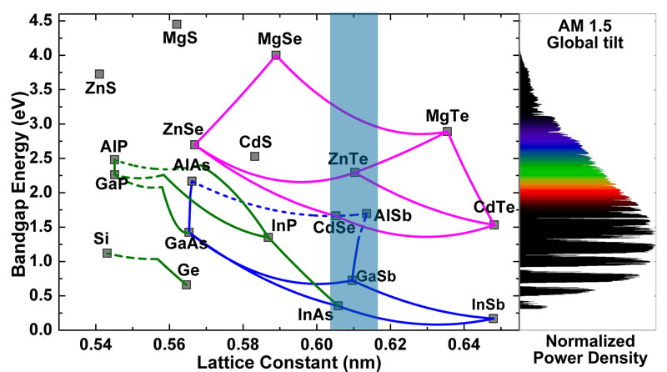
The II-VI materials are based on MgZnCdSSe.
A key initial advantage is that ZnSe is nearly lattice matched to GaAs meaning there is a natural substrate that should allow defect free growth. However, there were two key problems:
- It can be difficult to dope the material both p and n-type (especially p-type).
- The materials are quite “soft”. This means that the bonds are not strong and are easily broken, including under intense illumination such as in a laser diode.
This last problem proved more or less intractable, and these materials are no longer used for emitters. However, they are still researched for applications in making efficient solar cells (a kind of detector if you like)
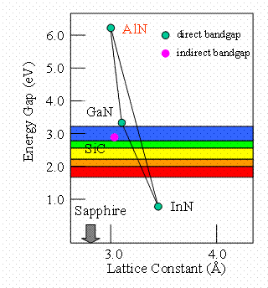
Initially III-nitride materials were ignored as potential emitting materials as there was no obvious natural substrate (meaning people thought defect problems would be too big an issue) and it has similar problems in doping it p-type. However, unusually the very strong bonds mean the defects are not the issue they are in other III-V materials and the doping problem was resolved. This led to LEDs, and eventually lasers using GaN with InGaN active regions to bring the bandgap of the emitter into the visible.
Today methods to prepare GaN and AlN on sapphire substrates are well understood. Indium containing materials are harder to control but thin layers can be prepared, as used for the active regions of LEDs and laser diodes.
The material is not cubic, but forms a hexagonal unit cell, so the values of the lattice spacing are not directly comparable with those above.
For blue and green emitting devices, GaN is used for the p and n regions and InGaN for the emitting region. The more In one adds the more strain there is. This leads to various problems including the formation of defects, which reduce the internal quantum efficinency. Thus blue LEDs are more powerful than the green ones. This leads to the so called “green gap” as Blue and Red LEDs are better performing than the green ones in the middle. However, as the eye is more sensitive in the green they can appear brighter!
For illumination we need white light. This can be achieved by placing a phosphor on a blue LED to convert some of the light into a green, yellow and red. Mixing these gives white light. As the efficiencies increase and costs come down more and more illumination applications are moving to this technology: examples are torches, monitor/TV backlights, Car headlights….
Finally note that AlN has a bandgap around 6 eV (around 210 nm) this allows UV LEDs to be made, which have application in analysis/detection systems, and ultimately potentially for water sterilisation (250 nm). This is an area of increasing research.

